**Managing your Azure AI Services Costs**

**Estimate costs before using Azure AI services**

Use the [Azure pricing calculator](https://azure.microsoft.com/pricing/calculator/) to estimate costs before you add Azure AI services.

1. Select a product such as Azure OpenAI in the Azure pricing calculator.

[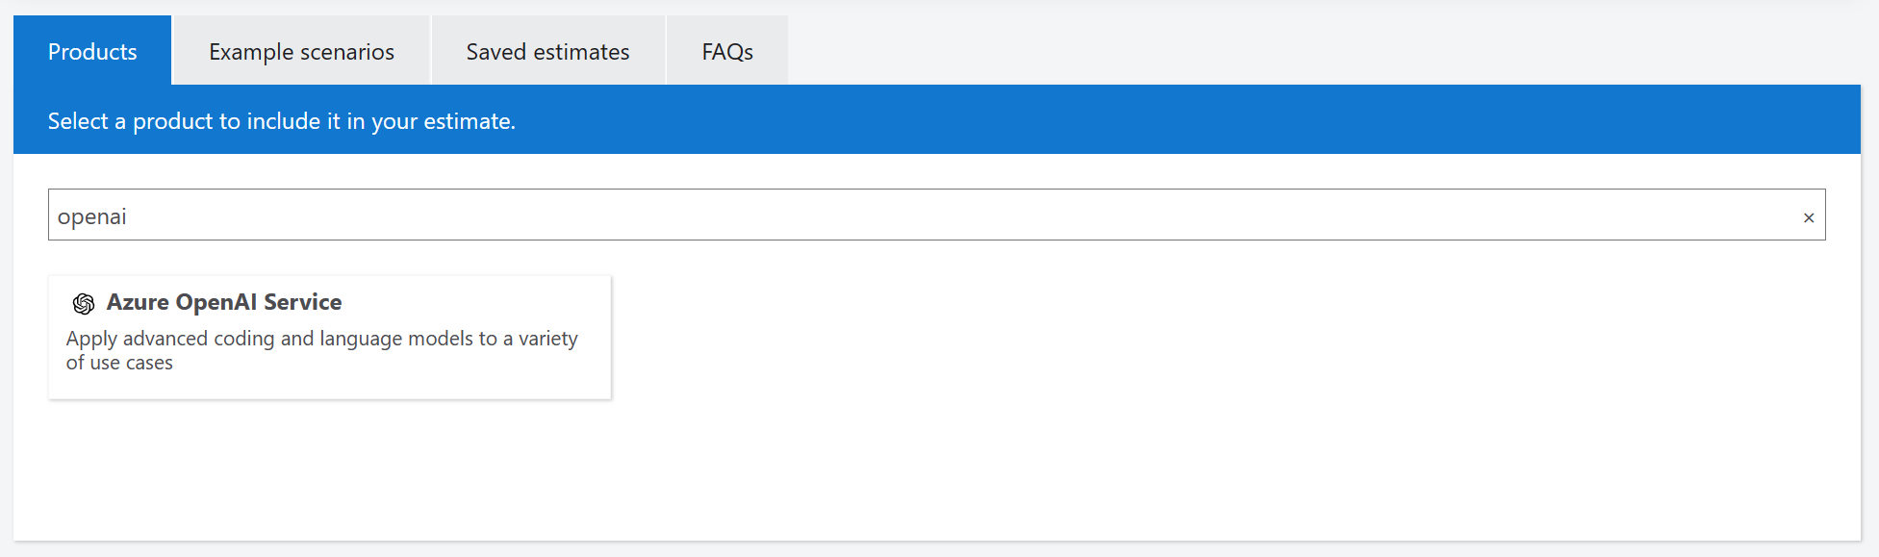](https://learn.microsoft.com/en-us/azure/ai-studio/media/cost-management/pricing-calculator-select-product.png#lightbox)

1. Enter the number of units you plan to use. For example, enter the number of tokens for prompts and completions.

[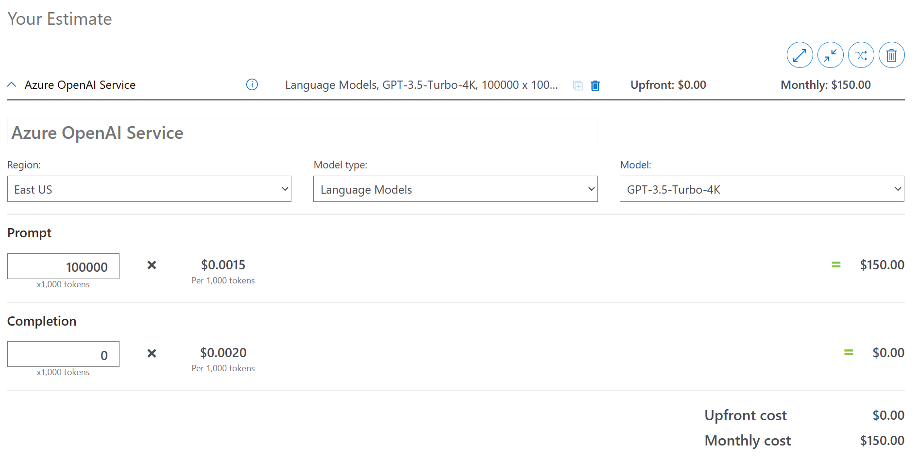](https://learn.microsoft.com/en-us/azure/ai-studio/media/cost-management/pricing-calculator-estimate-openai.png#lightbox)

1. You can select more than one product to estimate costs for multiple products. For example, select Virtual Machines to add potential costs for compute resources.

[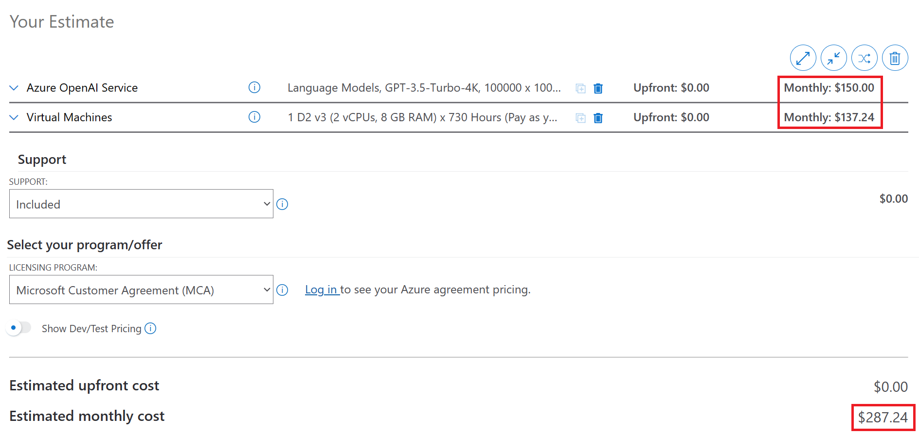](https://learn.microsoft.com/en-us/azure/ai-studio/media/cost-management/pricing-calculator-estimate.png#lightbox)

As you add new resources to your project, return to this calculator and add the same resource here to update your cost estimates.

**Monitor Azure AI Foundry project costs**

You can get to cost analysis from the [Azure portal](https://portal.azure.com/). You can also get to cost analysis from the [Azure AI Foundry](https://ai.azure.com/).

1. Sign in to [Azure AI Foundry](https://ai.azure.com/).
2. Select your project and then select **Management center** from the left menu.
3. Under the **Project** heading, select **Overview**.
4. Select **View cost for resources** from the **Total cost** section. The [Azure portal](https://portal.azure.com/) opens to the resource group for your project.

[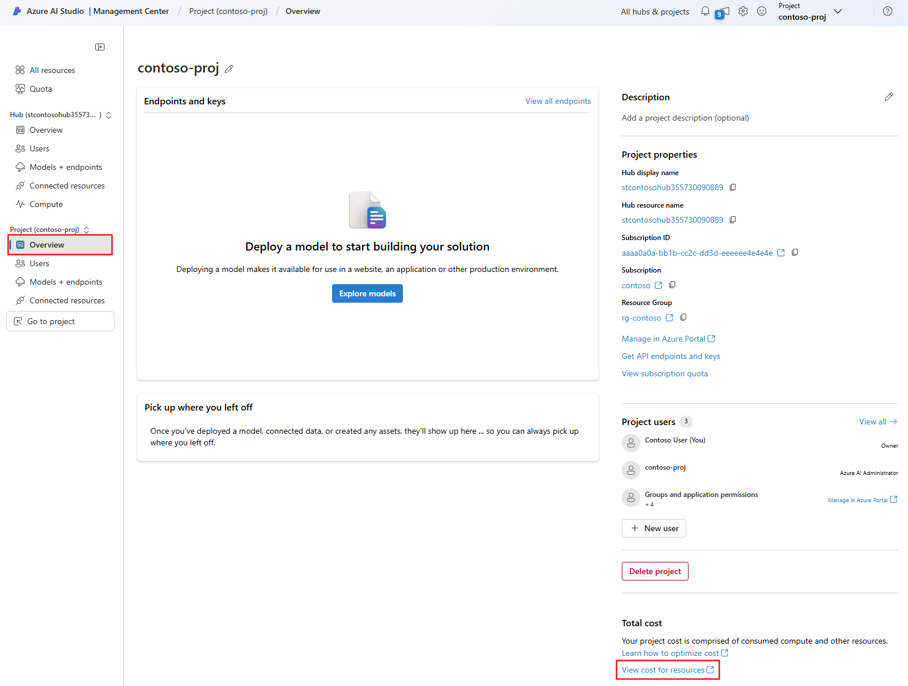](https://learn.microsoft.com/en-us/azure/ai-studio/media/cost-management/project-costs/project-settings-go-view-costs.png#lightbox)

1. Expand the **Resource** column to see the costs for each service that's underlying your [project](https://learn.microsoft.com/en-us/azure/ai-studio/concepts/ai-resources#organize-work-in-projects-for-customization). But this view doesn't include costs for all resources that you use in a project.

[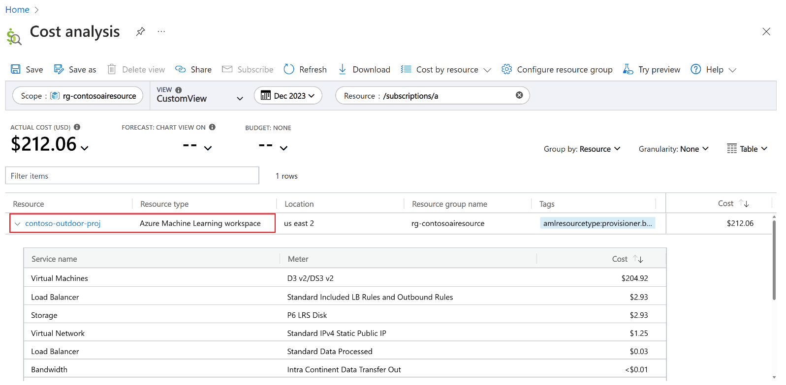](https://learn.microsoft.com/en-us/azure/ai-studio/media/cost-management/project-costs/costs-per-project-resource.png#lightbox)

1. Select **Costs by resource** > **Resources**.

[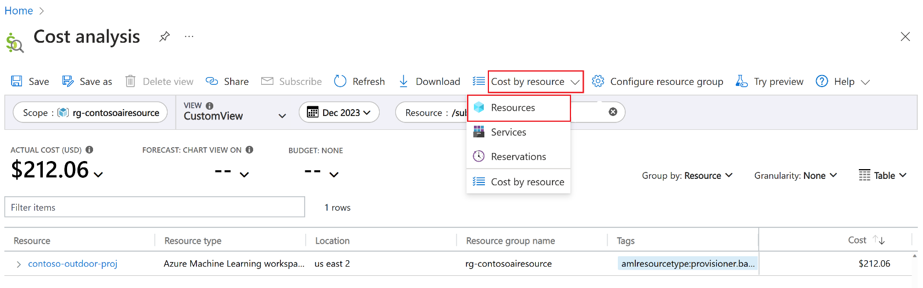](https://learn.microsoft.com/en-us/azure/ai-studio/media/cost-management/project-costs/select-costs-per-resource.png#lightbox)

1. On the **Cost analysis** page where you're taken to, make sure the scope is set to your resource group.

[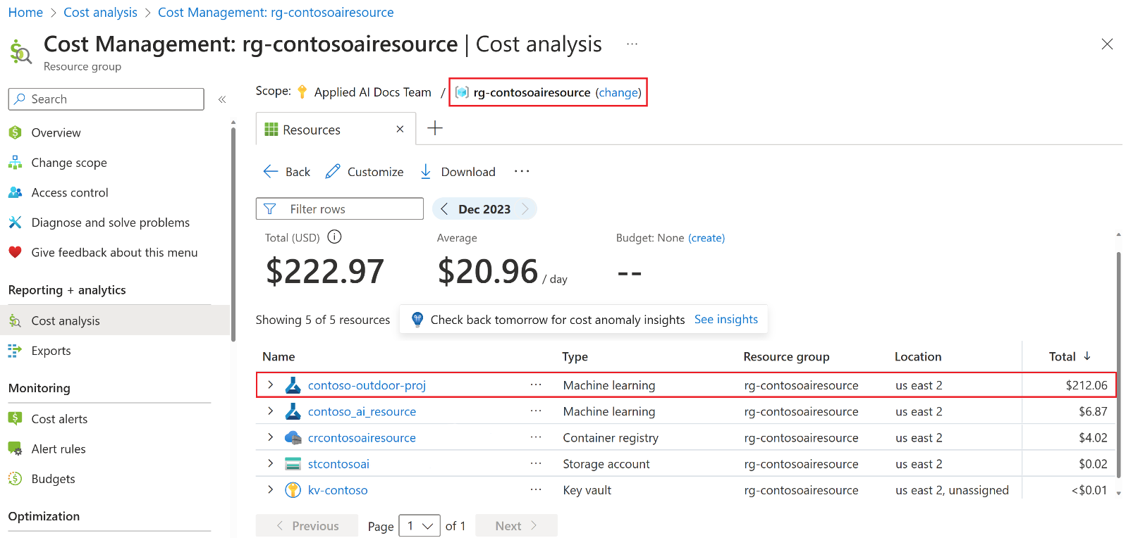](https://learn.microsoft.com/en-us/azure/ai-studio/media/cost-management/project-costs/costs-per-resource-group-details.png#lightbox)

In this example:

* + The resource group name is **rg-contosoairesource**.
  + The total cost for all resources and services in the resource group is **$222.97**. In this example, $222.97 is the total cost for your application or solution that you're building with Azure AI Foundry. Again, this example assumes that all Azure AI Foundry resources are in the same resource group. But you can have resources in different resource groups.
  + The project name is **contoso-outdoor-proj**.
  + The costs that are limited to resources and services in the [project](https://learn.microsoft.com/en-us/azure/ai-studio/concepts/ai-resources#organize-work-in-projects-for-customization) total **$212.06**.

1. Expand **contoso-outdoor-proj** to see the costs for services underlying the [project](https://learn.microsoft.com/en-us/azure/ai-studio/concepts/ai-resources#organize-work-in-projects-for-customization) resource.

[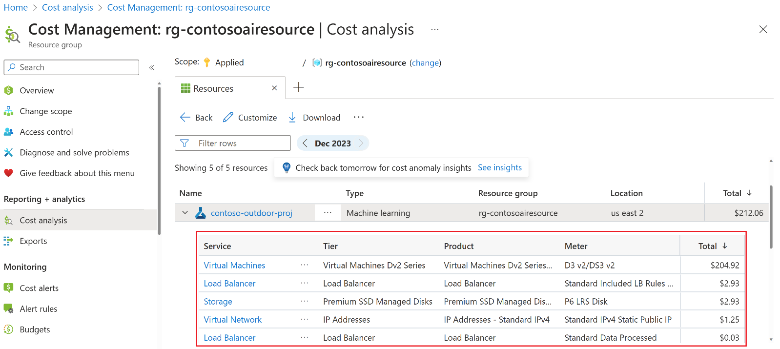](https://learn.microsoft.com/en-us/azure/ai-studio/media/cost-management/project-costs/costs-per-project-resource-details.png#lightbox)

1. Expand **contoso_ai_resource** to see the costs for services underlying the [hub](https://learn.microsoft.com/en-us/azure/ai-studio/concepts/ai-resources) resource. You can also apply a filter to focus on other costs in your resource group.

You can also view resource group costs directly from the Azure portal. To do so:

1. Sign in to [Azure portal](https://portal.azure.com/).
2. Select **Resource groups**.
3. Find and select the resource group that contains your Azure AI Foundry resources.
4. From the left navigation menu, select **Cost analysis**.

[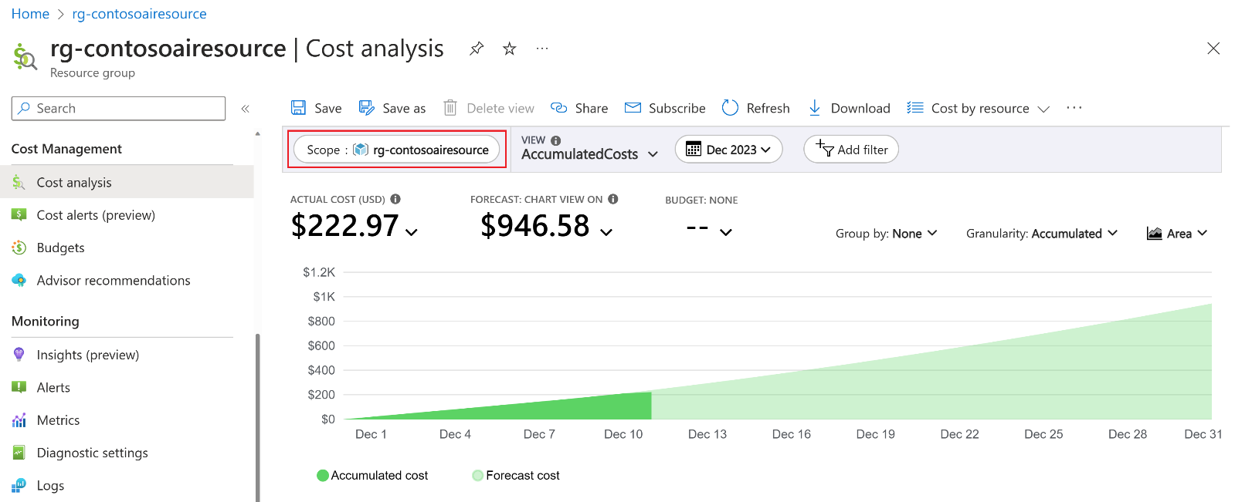](https://learn.microsoft.com/en-us/azure/ai-studio/media/cost-management/project-costs/costs-per-resource-group.png#lightbox)

**Monitor costs for models offered through the Azure Marketplace**

Models deployed as a service using pay-as-you-go are offered through the Azure Marketplace. The model publishers might apply different costs depending on the offering. Each project in Azure AI Foundry portal has its own subscription with the offering, which allows you to monitor the costs and the consumption happening on that project. Use [Microsoft Cost Management](https://azure.microsoft.com/products/cost-management) to monitor the costs:

1. Sign in to [Azure portal](https://portal.azure.com/).
2. On the left navigation area, select **Cost Management + Billing** and then, on the same menu, select **Cost Management**.
3. On the left navigation area, under the section **Cost Management**, select now **Cost Analysis**.
4. Select a view such as **Resources**. The cost associated with each resource is displayed.

[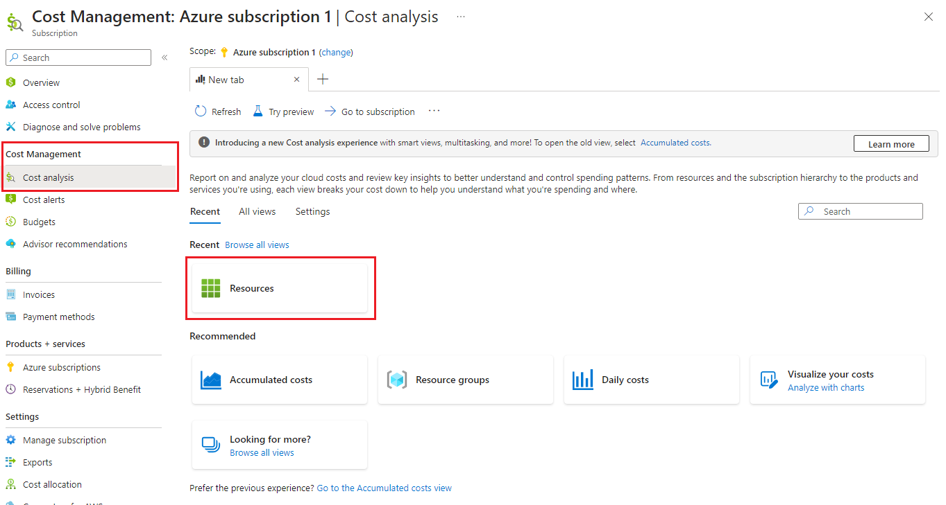](https://learn.microsoft.com/en-us/azure/ai-studio/media/cost-management/marketplace/costs-model-as-service-cost-analysis.png#lightbox)

1. On the **Type** column, select the filter icon to filter all the resources of type **microsoft.saas/resources**. This type corresponds to resources created from offers from the Azure Marketplace. For convenience, you can filter by resource types containing the string **SaaS**.

[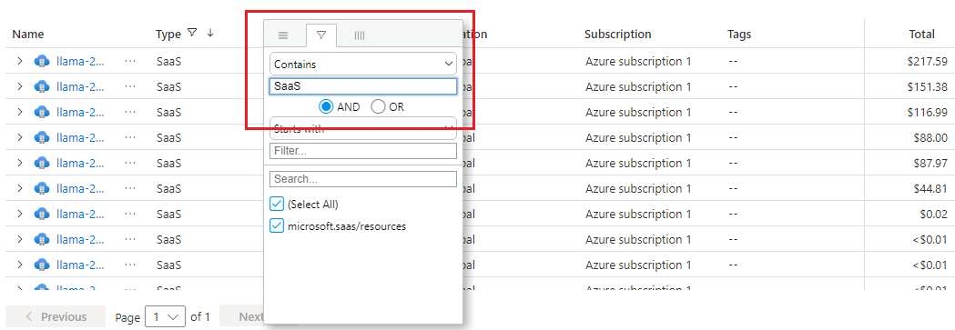](https://learn.microsoft.com/en-us/azure/ai-studio/media/cost-management/marketplace/costs-model-as-service-cost-filter.png#lightbox)

1. One resource is displayed for each model offer per project. Naming of those resources is [Model offer name]-[GUID].
2. Select to expand the resource details to get access to each of the costs meters associated with the resource.
   * **Tier** represents the offering.
   * **Product** is the specific product inside the offering.

Some model providers might use the same name for both.

[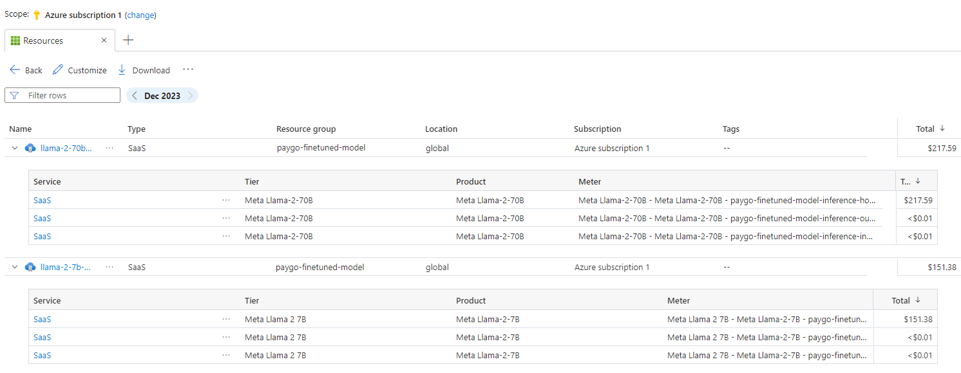](https://learn.microsoft.com/en-us/azure/ai-studio/media/cost-management/marketplace/costs-model-as-service-cost-details.png#lightbox)

1. When you expand the details, costs are reported per each of the meters associated with the offering. Each meter might track different sources of costs like inferencing, or fine tuning. The following meters are displayed (when some cost is associated with them):

**Create budgets**

You can create [budgets](https://learn.microsoft.com/en-us/azure/cost-management-billing/costs/tutorial-acm-create-budgets?WT.mc_id=costmanagementcontent_docsacmhorizontal_-inproduct-learn) to manage costs and create [alerts](https://learn.microsoft.com/en-us/azure/cost-management-billing/costs/cost-mgt-alerts-monitor-usage-spending?WT.mc_id=costmanagementcontent_docsacmhorizontal_-inproduct-learn) that automatically notify stakeholders of spending anomalies and overspending risks. Alerts are based on spending compared to budget and cost thresholds. Budgets and alerts are created for Azure subscriptions and resource groups, so they're useful as part of an overall cost monitoring strategy.

Budgets can be created with filters for specific resources or services in Azure if you want more granularity present in your monitoring. Filters help ensure that you don't accidentally create new resources that cost you more money. For more about the filter options when you create a budget, see [Group and filter options](https://learn.microsoft.com/en-us/azure/cost-management-billing/costs/group-filter?WT.mc_id=costmanagementcontent_docsacmhorizontal_-inproduct-learn).

**Export cost data**

You can also [export your cost data](https://learn.microsoft.com/en-us/azure/cost-management-billing/costs/tutorial-export-acm-data?WT.mc_id=costmanagementcontent_docsacmhorizontal_-inproduct-learn) to a storage account. Exporting data is helpful when you or others need to do more data analysis for costs. For example, finance teams can analyze the data using Excel or Power BI. You can export your costs on a daily, weekly, or monthly schedule and set a custom date range. Exporting cost data is the recommended way to retrieve cost datasets.

**Understand the full billing model for Azure AI services**

Azure AI services run on Azure infrastructure that accrues costs along with Azure AI when you deploy the new resource. It's important to understand that extra infrastructure might accrue cost. You need to manage that cost when you make changes to deployed resources.

When you create or use Azure AI services resources, you might get charged based on the services that you use. There are two billing models available for Azure AI services:

* Pay-as-you-go: Pay-as-you-go pricing, you're billed according to the Azure AI services offering that you use, based on its billing information.
* Commitment tiers: With commitment tier pricing, you commit to using several service features for a fixed fee, enabling you to have a predictable total cost based on the needs of your workload. You're billed according to the plan you choose. See [Quickstart: purchase commitment tier pricing](https://learn.microsoft.com/en-us/azure/ai-services/commitment-tier) for information on available services, how to sign up, and considerations when purchasing a plan.